# **Keeping Tabs on Your Kids: The Latest Parental Controls From Apple, Google and Amazon**

## **Parents who want to set content filters and control who their kids text should start with the built-in settings on their devices**

*By*

*Julie Jargon, Wall Street Journal*

Sept. 17, 2019 8:00 am ET

Many parents ask how they can keep tabs on their children online without shelling out a lot of money—and without major headaches, especially when juggling multiple devices for multiple children. The first step isn’t to buy expensive software, but to look at the devices themselves.

The settings sections of common household Apple and Amazon devices, along with those that run Google’s Android and Chromebook software, allow parents to do everything from block explicit content to set a fixed gadget bedtime—all without paying extra or ceding privacy to an outside service.

This week, with the expected rollout of [Apple’s iOS 13](https://www.apple.com/ios/ios-13/features/?mod=article_inline), parents will more easily be able to set time limits on individual iPhone, iPad and iPod Touch apps. Later this fall, Apple will launch its most compelling upgrade: the ability to manage children’s contacts and control who they can communicate with.

Google recently extended its Family Link parental controls to teens and made it a part of the latest Android operating system, and Amazon continues to develop the voice assistant in the Echo Dot Kids Edition, which has the same parental controls as its kids’ Fire tablets.

Before you go too crazy turning on controls, proceed with a megabit of caution. Family media experts advise parents to begin with more stringent controls when children first get internet-connected devices, then relax them as kids demonstrate maturity.

“We call them digital on-ramps. When your child is really young, talk to them about everything they do with a device. When you snap a photo, talk about whether you’re sharing it with Grandma, so it becomes embedded in their everyday practice of using devices,” said Diana Graber, author of “Raising Humans in a Digital World: Helping Kids Build a Healthy Relationship with Technology.”

It’s much harder, she said, to impose controls once kids have tasted freedom.

Researchers at the University of Central Florida last year found that [too much parental control fosters distrust](http://www.eecs.ucf.edu/~jjl/pubs/pn1838-ghoshA.pdf?mod=article_inline) and encourages kids to do the very things digital controls were designed to prevent.

What these settings won’t do is tell you [what your kids are seeing or posting online](https://www.wsj.com/articles/safe-space-or-police-state-how-far-should-you-go-in-monitoring-your-kids-online-11559640600?mod=article_inline). That is where third-party services like Bark, which charge fees to monitor kids’ online activities, come into play.

Also, remember that tech companies tend to treat teens as adults, because of a [decades-old online privacy law](https://www.wsj.com/articles/how-13-became-the-internets-age-of-adulthood-11560850201?mod=article_inline), so managing their activities becomes harder. And of course, teens are notorious for finding workarounds to even the most sophisticated parental controls. Just as previous generations got around curfew by sneaking out of basement windows late at night, today’s digital natives can venture out online by disabling settings, [creating fake social media accounts and smuggling burner phones](https://www.wsj.com/articles/teens-smuggle-burner-phones-to-defy-parents-11557826201?mod=article_inline).

Still, it’s best to take a catalog of the devices in your kids’ lives, and know the basic parental-control settings for all of them.

###### **Apple: iPhone, iPad and iPod Touch**

Even though [Apple](https://quotes.wsj.com/AAPL) Inc. [AAPL +0.59%](https://quotes.wsj.com/AAPL?mod=chiclets)introduced parental controls for the iPhone back in 2008, its big leap into this space came last year with iOS 12. With the introduction of Screen Time, parents can track their kids’ device usage, set time limits for categories of apps, such as games or social networking, and schedule downtime for their kids’ devices.

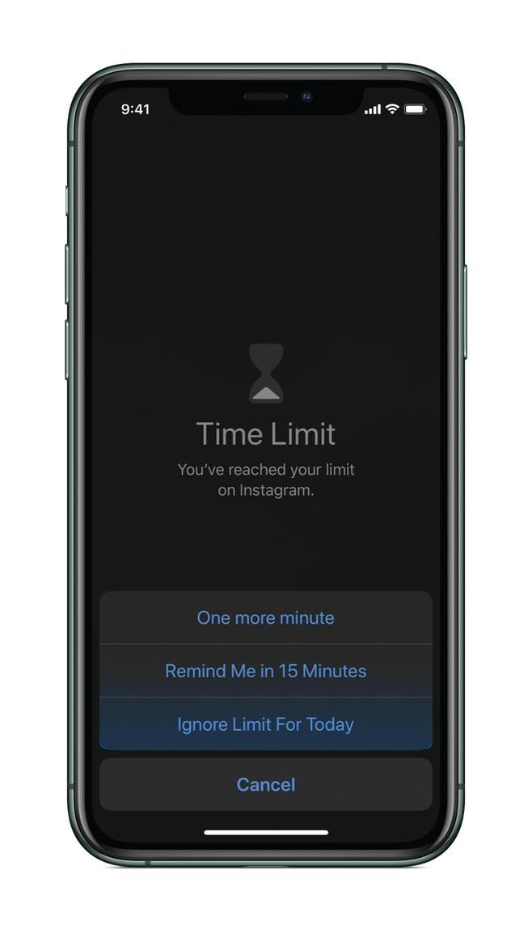

Apple's new iOS 13, expected to launch this week, has a feature that allows people to tap ‘one more minute’ when a Screen Time limit is met, giving them a chance to finish playing a game or scrolling social media. PHOTO: APPLE

Starting Thursday with iOS 13, parents will be able to more easily create time limits for specific apps within the “app limits” section of Screen Time. Parents previously had to search for specific apps in their child’s usage report, which went back only seven days. And now, they also will be able to track usage data for a month instead of a week.

Apple said it would update Screen Time further later this fall, giving parents control over who their children can text, call and FaceTime—and who can communicate with them—by managing their kids’ contacts. Kids won’t be able to bypass the controls by entering phone numbers manually. And parents will be able to get in touch with their kids, even when their devices are otherwise locked down.

Having no control over who kids can communicate with is a common complaint among parents, according to Christine Elgersma, senior editor of parent education at Common Sense Media.

Another complaint? Children whining when the game they are playing suddenly shuts down because they have reached a preset time limit. The new iOS has a feature that allows kids to tap “one more minute” when the Screen Time limit is met, giving them a chance to finish what they were doing.

###### **Google: Chromebooks and Android phones and tablets**

[Alphabet](https://quotes.wsj.com/GOOG) Inc. [GOOG -0.14%](https://quotes.wsj.com/GOOG?mod=chiclets)’s Google has an [app called Family Link](https://families.google.com/familylink/?mod=article_inline), designed to allow parents to create and manage Google accounts for children under 13.

It allows parents to set screen-time limits, approve app downloads and set a bedtime for their devices. Parents also can see apps that are recommended by teachers.

So what happens if a teenager has a normal Gmail account, instead of one created under Family Link? Parents can still use the Family Link app to manage that teen’s account. Just follow the steps to [add a child with an existing Google account](https://support.google.com/families/answer/9055704?hl=en&mod=article_inline).

Family Link will now be accessible from the settings of every device running Android 10, which was released earlier this month, initially on Google’s Pixel phones. Here’s the rub: Teens must agree to allow parental supervision and can turn it off, though Google will alert parents if they do.

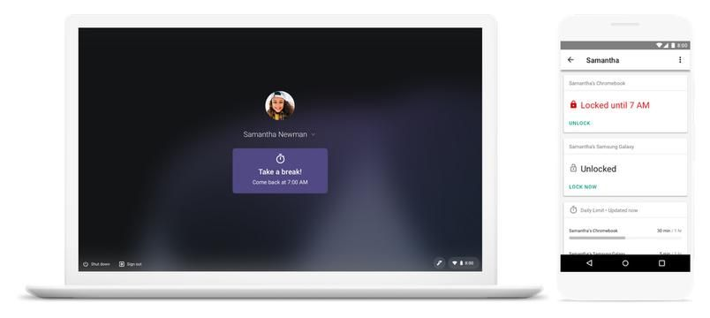

Google’s Family Link app lets parents set screen-time limits and a bedtime for kids’ Chromebooks as well as devices that run Android. PHOTO: GOOGLE

###### **Amazon: Fire tablets and the Echo Dot Kids Edition**

For younger children using Fire Kids Edition tablets, [Amazon.com](https://quotes.wsj.com/AMZN) Inc. [AMZN -0.55%](https://quotes.wsj.com/AMZN?mod=chiclets)offers multiple controls under its no-charge FreeTime app. The FreeTime app is included on all Fire tablets, since many kids also use their parents’ tablets. (Parents can upgrade the app by paying a monthly fee to get FreeTime Unlimited, which provides subscribers with e-books, audiobooks and other curated content.)

Beyond the usual bedtime, screen-time and app limits, [FreeTime allows](https://www.amazon.com/gp/help/customer/display.html?nodeId=GNTST5RQEYKPGLYE&mod=article_inline" \t "_blank) parents to create up to four children’s profiles per tablet and to customize age filters so that each child sees only corresponding age-appropriate content.

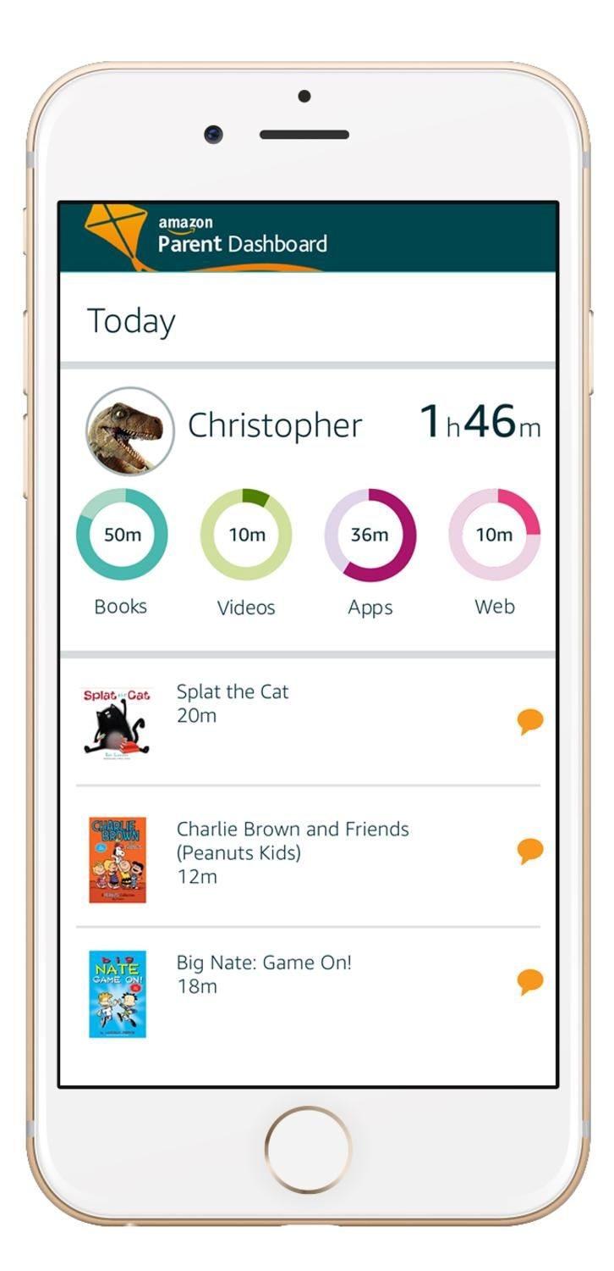

Amazon allows parents to track how much time their children spend on apps and set goals for educational content. PHOTO: AMAZON

Parents can set daily goals for educational content, blocking access to entertainment apps until after the day’s educational goals are met. They also can set different time limits for different activities, allowing more time, say, for reading than for games. And they can disable the web browser.

For kids using the Echo Dot Kids Edition, parents can create the same controls as they can in the tablets, as well as filter songs with explicit lyrics.

Even with all of these handy built-in settings, family media experts and tech executives alike say that nothing replaces the lessons parents can teach kids about safe and responsible internet usage.

“No matter how good the product is, it’s super important that parents talk to their kids,” said Kurt Beidler, director of Kids and Family at Amazon. “No product is the magic pill.”

**Write to**Julie Jargon at [julie.jargon@wsj.com](mailto:julie.jargon@wsj.com)

Copyright ©2019 Dow Jones & Company, Inc. All Rights Reserved. 87990cbe856818d5eddac44c7b1cdeb8